Université d’Ottawa

Faculté de génie



University of Ottawa

Faculty of Engineering

**Group Final Project**

**Q&A Mental Care Chatbot System**

**1 Group Member**

**He Zhixin**

Student ID: 300142825

Responsibility: Feature Extraction, Clustering Error Analysis, Recommend Engine Development, Report Writing

**Lin Wenqi**

Student ID: 300201446

Responsibility: Chatbot GUI Development, Training Model Development, Parameter Optimization, PPT making

**Pang Yuxue**

Student ID: 300177911

Responsibility: Raw Data Processing, Classification Error Analysis, Confusion Matrix Design, Report Writing

**Qin Kun**

Student ID: 300188345

Responsibility: Classification Model Prediction, Confusion Matrix Optimization, Chatbot GUI Development, Code Organization

**2 Problem Formulation**

Mental health is arousing more and more attention these years. In Canada, approximately one in five people suffer from mental health illness**. Nearly 50%** of citizens from age 40 say that they had or are experiencing mental health problem. The most effective measure to cope with mental issue is to see psychologist. However, it is necessary for people to know **self-diagnosis** when it is hard to see the doctor at once. By teaching people some basic emotion evaluation, it is also helpful for doctor to quickly understand the current mental status of patients in depth. That is our purpose to design Q&A mental care chatbot. We believe that people will be better at protecting themselves after using the chatbot system. it will give patients an appropriate answer for each question and provide some similar questions for further asking.

**3 Prepare the data and process the data:**

Firstly, in order to get the original data, our group used mental health dataset provided by Kaggle, which has several csv files. Secondly, our goal is to generate 98 question label groups, each group has 5 similar questions.

To do this, we firstly import 98 questions and their corresponding answers. Then, we extend each question into a group by adding 4 another similar records. In all, the dataset has 98 question group with 490 records. Finally, we used the **word_tokenize** function to get the 490*485 target record words. We also clean the stops words by using stop words list generated before.

To easily process the data of all question records, we defined a function named **“csvDataProcess”** to do that, it has one parameter for verifying the specific name of csv file.

**4 Transform**

To deal with the records, our group used the Bag of Words (BOW), TF-IDF and LDA (Latent Dirichlet Allocation) methods to realize it. We plan to utilize 485 records to finish the transformation.

**4.1 Feature words extraction**

For the BOW method, we used **CountVectorizer()** to transform the words in the text in to the matrix of the frequency of words, and used **fit_transform** to calculate the frequency of each word. After transformation, **toarray** function was used to generate a numpy array.

Similar to BOW, in TF-IDF method, TfidfTransformer() class and its related functions were used to build to calculate the value of TF-IDF of each word. In addition, LDA was implemented from the library of sklearn.decomposition, and the parameters of this function was set as follows n_components=98, max_iter=50, learning_method='batch'.

**4.2 Building labels for Question Groups**

We build a numpy array to storage the labels of each question group, we use **range(98)** to list numbers from 0 to 97 represent for each book, and the length of each number is 5, representing 5 similar questions. So, the total length of this array is 98*5 = 490.

**5 Machines Classification and Evaluations with SVM, KNN and DC**

After section 4.1 and 4.2, we use train_test_split function to split data into training part and test part. Then training data and test was put into different machines (SVM, KNN and DC) to train and test.

**5.1 Classification Algorithm Parameters Setting**

The parameters of SVM, KNN and DC were set as below. We adjust parameters by ourselves in order to achieve the maximum accuracy.



Fig 1. Parameters of SVM using BOW



Fig 2. Parameters of SVM using TF-IDF



Fig 3. Parameters of KNN using BOW



Fig 4. Parameters of KNN using TF-IDF



Fig 5. Parameters of DC using BOW



Fig 6. Parameters of DC using TF-IDF

**5.2 Evaluation for SVM, KNN and DC**

**5.2.1 Using accuracy to evaluate models**

Accuracy was used to evaluate the performance of each machine, which is shown in the below table.

TABLE I EVALUATION USING ACCURACY

|  |  |  |
| --- | --- | --- |
| Transform Method  Training Machine | BOW | TF-IDF |
| SVM | 0.71 | 0.69 |
| KNN | 0.68 | 0.75 |
| DC | 0.66 | 0.63 |

For a further evaluation, we used five times Cross Validation to compare the models, the results are shown below, and we can see that SVM using TF-IDF shows the best accuracy this time, which is different from the above verification. Because cross-validation can bring more reliable results, we think that TF-IDF with SVM tends to have the best accuracy among all models.

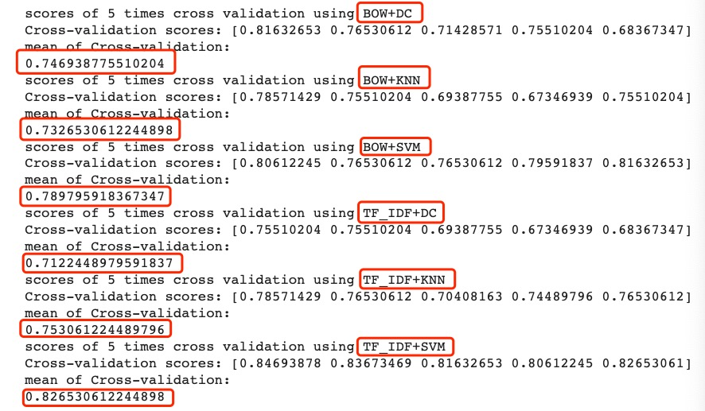

Fig 7. Five Times Cross Validation of Each Model

**5.2.2 Prediction of input data**

First, we randomly chose a question in our question list, then it was transformed into an array of vector, and put it in the prediction of each model, as a result, every model can tell the answer of the question. The paragraph shown below is the test data and result:

***“What is mental health?” =>We all have mental health which is made up of our beliefs, thoughts, feelings and behaviors.***

We can see that the all the six machines can tell us the correct answer of the chose question, which means that our SVM, KNN and DC models are accurate enough to do this work.

**6 Machines Clustering and Evaluations with K-Means, EM and AC**

After section 4.1 and 4.2, the original input data was generated for those K-Means, EM and HC models. **However, when we were testing the EM algorithm, the RAM of the virtual machine of CoLab overloaded, due to the high dimensions of the input data.** Therefore, in order to make sure the program could run correctly, we decreased the dimension of the original data through the PCA method for TF-IDF and BOW.

**6.1 Clustering Algorithm Parameters Setting**

The parameters of K-Means, EM and AC functions were set as below. We adjust parameters by ourselves in order to achieve the maximum accuracy.



Fig 8. Parameters of K-Means



Fig 9. Parameters of EM

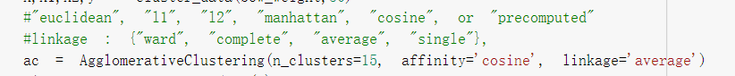

Fig 10. Parameters of AC

**6.2 Evaluation for KM, EM and HC**

For the evaluation of the clustering, **Kappa, Consistency, Coherence and Silhouette** were used in our program in order to compare the different clustering methods. The result of these evaluation methods was shown below.

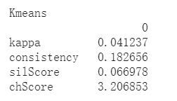

Fig 11. The Evaluation of Kappa, Consistency, Coherence and Silhouette with the BOW-KMeans

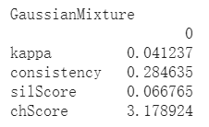

Fig.12. The Evaluation of Kappa, Consistency, Coherence and Silhouette with the BOW-GM

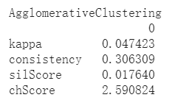

Fig.13. The Evaluation of Kappa, Consistency, Coherence and Silhouette with the BOW-AC

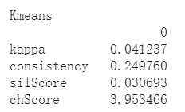

Fig 14. The Evaluation of Kappa, Consistency, Coherence and Silhouette with the TF-IDF-KMeans

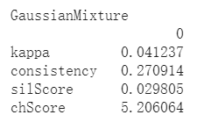

Fig 15. The Evaluation of Kappa, Consistency, Coherence and Silhouette with the TF-IDF-GM

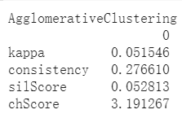

Fig 16. The Evaluation of Kappa, Consistency, Coherence and Silhouette with the TF-IDF-AC

From the picture shown above, we can see that the TF-IDF has the overall better clustering with K-Means, EM and AC than BOW. However, the general evaluation result is not very good. For example, the kappa always keeps in a very low level. We suppose that it should be related to the dataset our choose. The dataset does not have a very big volume. During the clustering, the machine does not have sufficient resources to finish the training. This might cause that the accuracy is always in a low level. Another reason is that our dataset focuses on the mental health. There is no doubt that each question has a limited correlation with others. After data cleaning, it is possible that some questions have similar feature words but asking in different aspects. When the machine confronts this situation, it is likely to regard them as similar group. Therefore, the evaluation result naturally cannot meet our expectations.

**7 Error analyzation**

**7.1 High frequency words**

To realize this part, first, we used the test set as the input of the **error_analysis** function, then the machine predicts answers about input questions through the clustering algorithms. If the predicted answers do not match the actual questions. This answer is a wrongly predicted answer, and then the word frequency of the feature words is calculated for this wrong answer. Then the top 10 most frequent feature words were found, which means these feature words are easily misjudged by machines.

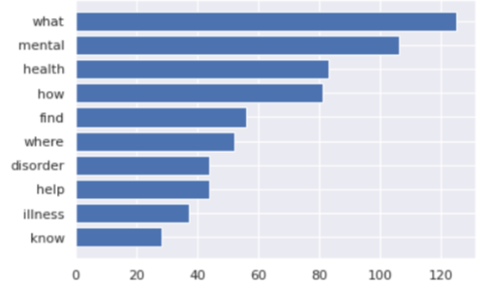

Fig 17. Top 10 Frequency Words through BOW+KMeans

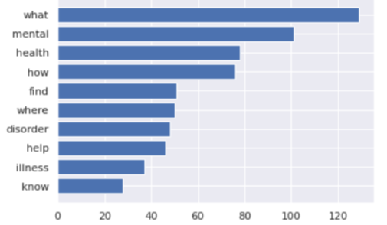

Fig 18. Top 10 Frequency Words through BOW+EM

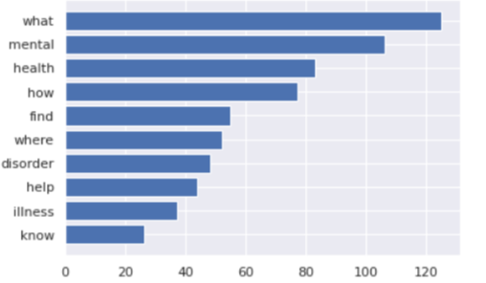

Fig 19. Top 10 Frequency Words through BOW+HC

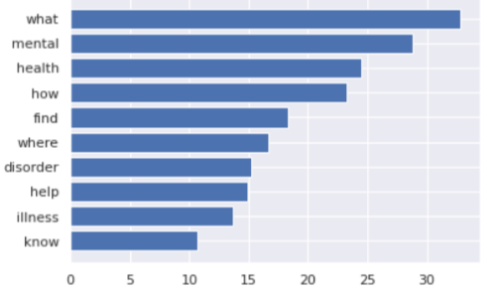

Fig 20. Top 10 Frequency Words through TF-IDF+KMeans

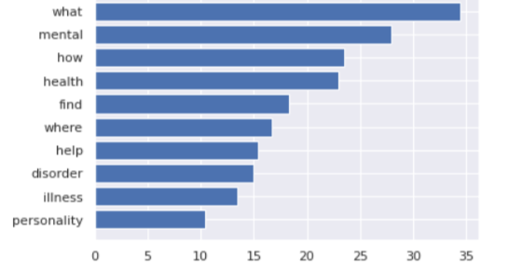

Fig 21. Top 10 Frequency Words through TF-IDF+EM

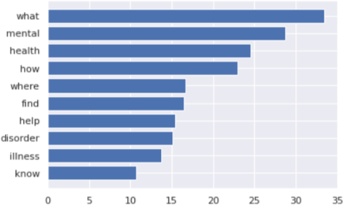

Fig 22. Top 10 Frequency Words through TF-IDF+HC

Like the picture shown above, some of the words are pretty common when we used the BOW transform, like “what”, “mental”, “health” and etc., which we thought these words do not have the particular characteristic for all those questions, and we consider those words should also be stop-words, then we filtered those word, and redefine them as the new stop-words in addition to the stop-words form the NLTK library. After the filtering work, we run the clustering model again, in order to compare the “common words” effect.

**7.2 Confusion Matrix**

After Clustering, our group also used the **Confusion Matrix** to help us find the relationships among different models.

**TF-IDF analyzation:**

For the TF-IDF + SVM model, we can see that, the machine has some problems about distinguishing questions from 66 to 72, as well as from 12 to 24, which means these question groups may have some similarity with other questions. The machine misunderstands these questions as others. This situation also occurred in KNN and DC models. In general, the distributions of three models are all like a diagonal starting from the upper left to the bottom right. This means the model we designed are all in a good accuracy. The prediction is right in most of question groups.

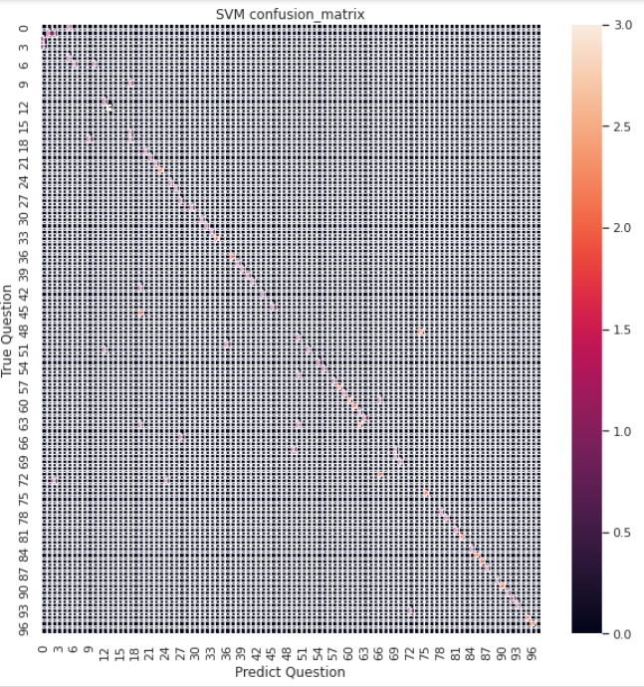

Fig 23. Confusion Matrix of TF-IDF+SVM

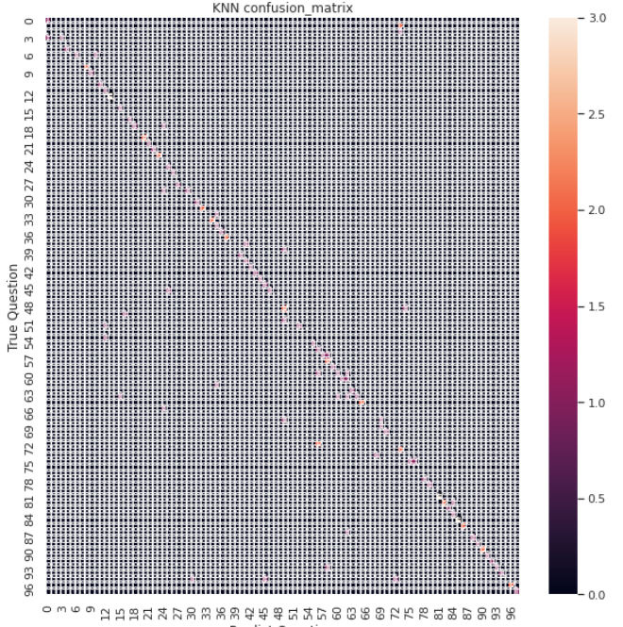

Fig 24. Confusion Matrix of TF-IDF+ KNN

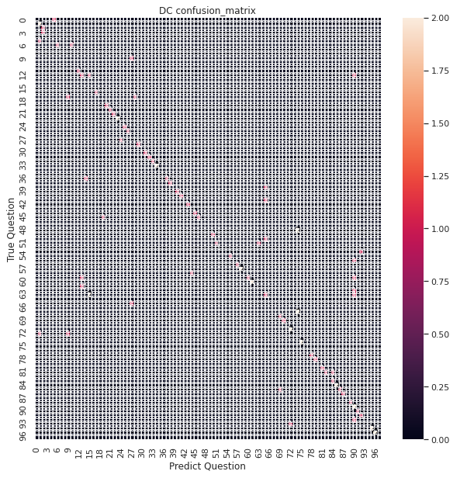

Fig 25. Confusion Matrix of TF-IDF+ DC

**BOW analyzation:**

We can see that when the machine used SVM clustering, it failed to distinguish questions from 60 to 72, the phenomenon is similar with TF-IDF transformation, some other questions group were also failed to be identified. Both KNN and DC model has a complete line shape, which shows better performance than SVM. However, the distribution of SVM confusion matrix is more concentrated near the diagonal than that of KNN and DC. We can know that question group in SVM model are more often identified as neighbor groups.

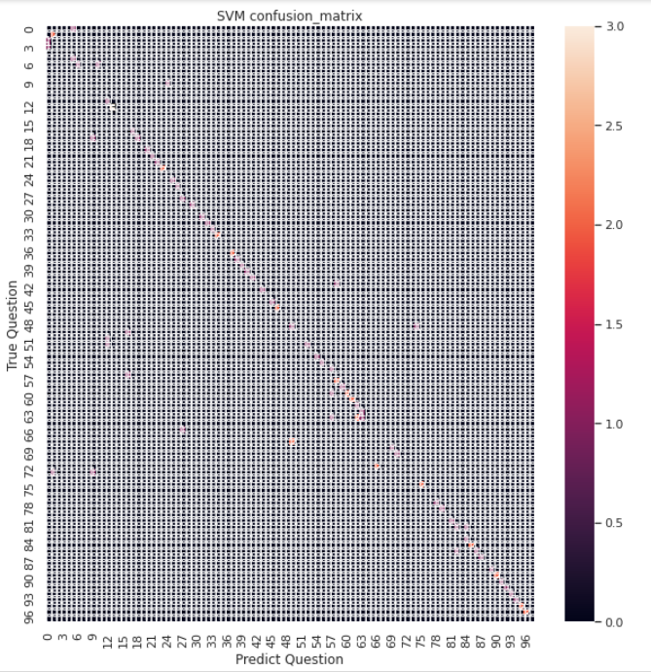

Fig 26. Confusion Matrix of BOW +SVM

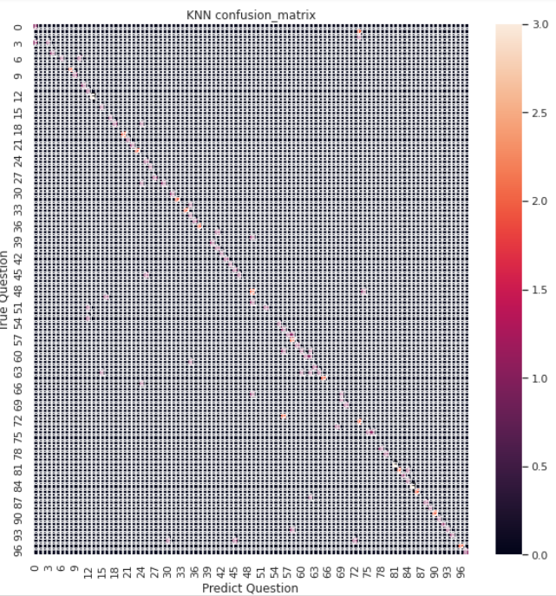

Fig 27. Confusion Matrix of BOW+KNN

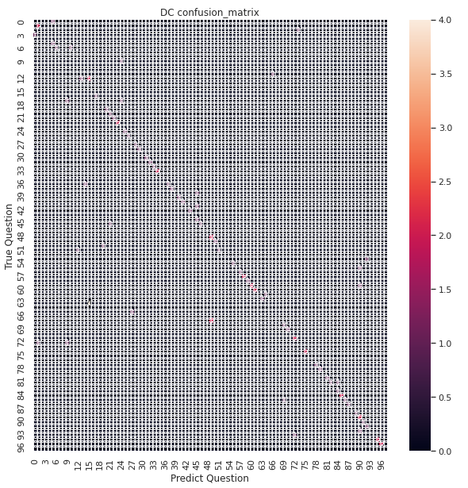

Fig 28. Confusion Matrix of BOW+DC

**8 Recommend Engine**

From all classification and clustering models, we know that SVM with TF-IDF can provide results with the best accuracy, so in this part, we use confusion matrix generated in the error analysis part as input data of recommend engine. By choosing predicted questions which similarity is higher or equals to 1, we can generate a file named SVM_confusion.csv which have three columns named ‘trueQuestion’ ‘predictQuestion’ and ‘similarity’ separately. After that we imported relevant algorithms such as SVD and NMF to build recommend engine, the table below shows some running parameters of different algorithms.

TABLE II. RUNNING PARAMETERS OF DIFFERENT RECOMMEND ALGORITHMS

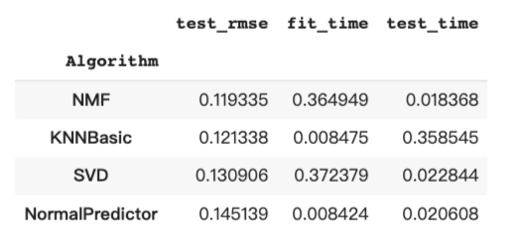

Then a function called svm_prediciton was built to process raw input question and its main work is to give a predict question by using SVM with TF-IDF model to recommend engine. After recommend engine receives input question, it will output five recommend questions according to our similarity question list and its own algorithm. To evaluate the engine,we randomly chose a question called “What is mental illness”, and its 5 recommend questions can be seen as below:

'Who can be influenced by mental illness',

'What increases the possibility of mental illness',

'What may make mental illness happen',

'Give me some information about different mental health professionals',

'How can I find a mental health expert for my friends'

From the above test results, we can see that the engine tells us five relevant questions and they are all related to the actual question which means that the recommend engine is accurate enough to do this work.

**9.Inovative Part: GUI Front End System Development**

In this part, our group used the ***anvil*** online platform to realize the GUI development. Anvil is a platform that can be connect with google colab to do amazing front end display. After the programming as well as the web page design of the anvil, this platform can generate an authoration code, which can help the colab connect with anvil.

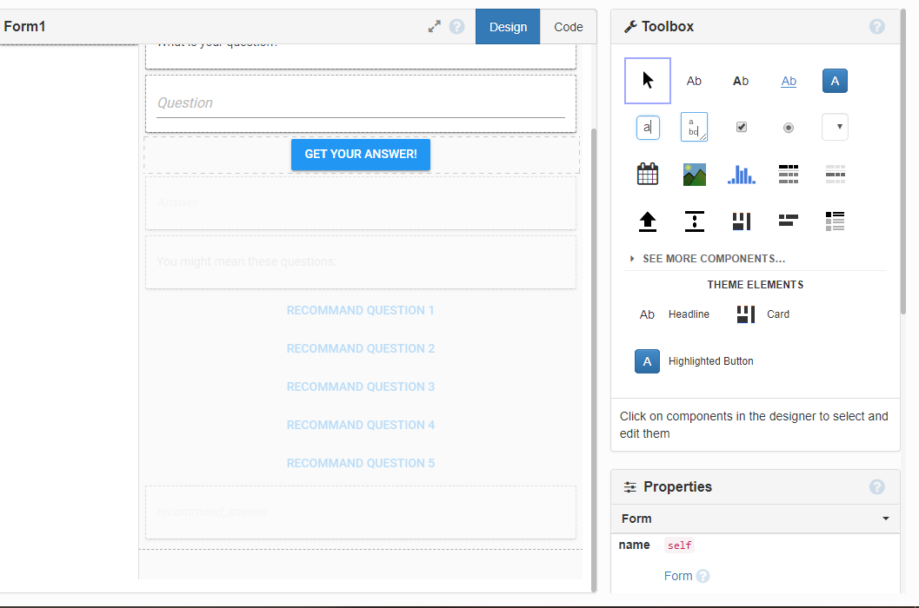

Fig 29. Web Page Design of Anvil

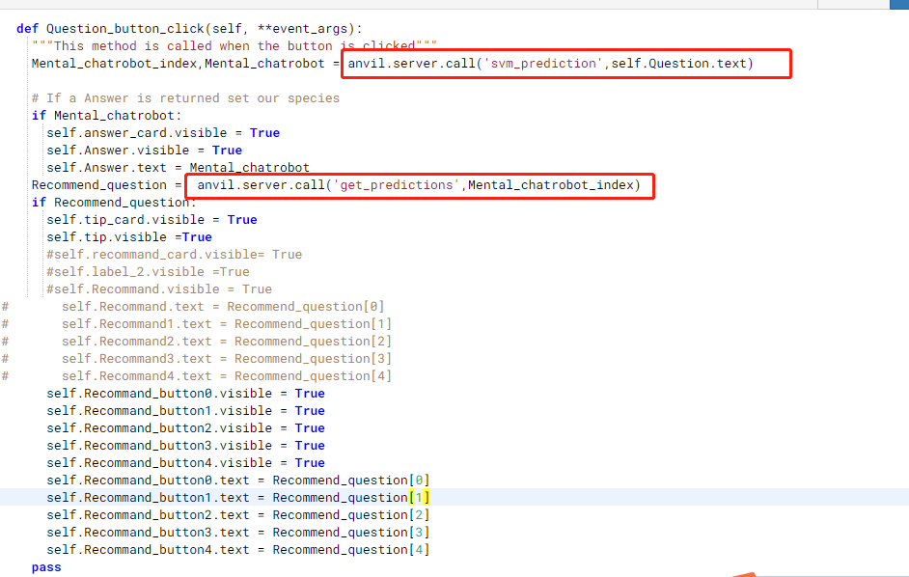

Fig 30. Anvil Web Page Python Programming

Then, whatever function we want to call in the colab, the only thing we need to do is add this code top of the function ***@anvil.server.callable*** to further develop it in the anvil we used the function  ***“anvil.sever.call”*** to call the colab function.

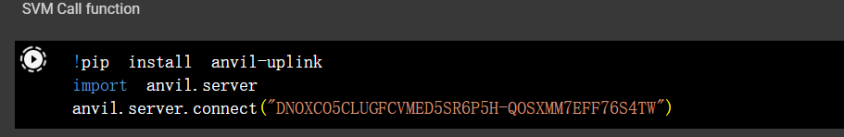

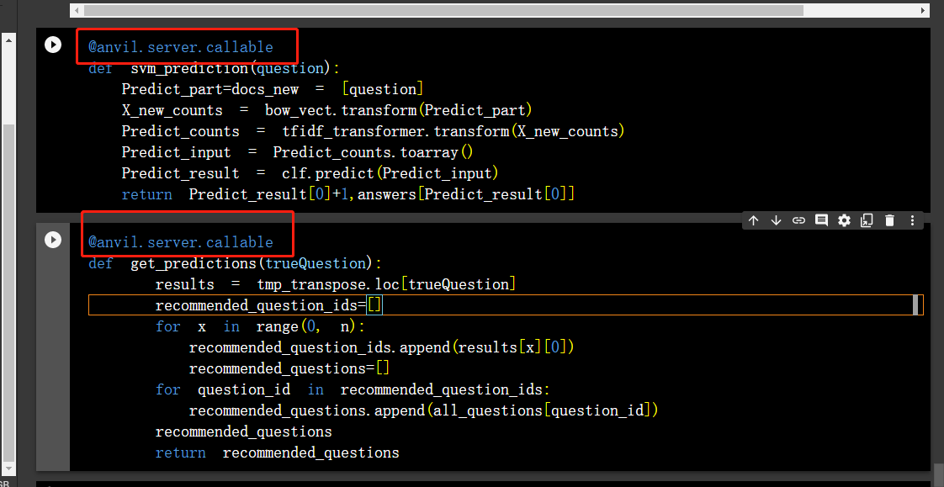

Fig 31. Colab Connects with Anvil

When user inputs questions, the Anvil will read the question and send it as the local varible to the colab prediction function, then the predicion function will return the answer index and the anwser text, the anvil will first display the answer, after that, it will send the index number to the recommend engine(in colab), then the engine will return 5 reommended questions and display them with the format of 5 buttons, if the user clicks the one of the buttons, the anvil will call the prediction function again, and display the recmmendation answer.



Fig 32. Flow Chart of the GUI system

The final GUI front end is like this:

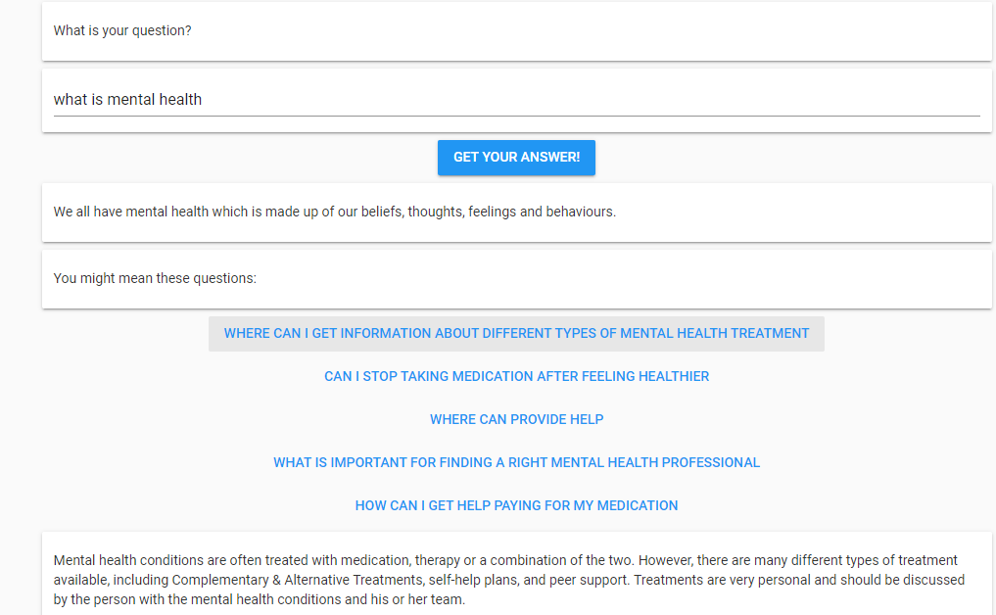

Fig 33. GUI System Display

**10 Conclusion**

From the former chapters, the conclusion can be drawn as follows:

(1) All of three classification models show great performance in both BOW and TF-IDF transform. The distribution shape like a diagonal, which means the machine predicts most of questions correctly.

(2) The clustering result does not meet our expectation. The main reason is that the dataset does not have a great volume.

(3) For error analysis, we still redefine the stops words and add them to the original set. It truly improves the accuracy but the increase is not evident. We do not mention the result in the paper.

(4) We design a GUI interface to provide more friendly service experience to users. The platform is provided by ***anvil.*** We implement the drive and callable service by Python.